Amino acids
Amino acids are organic compounds that combine to form proteins. They are the Called the "building blocks of life," amino acids can be obtained in healthy amounts by eating foods that contain them. Amino acids are compounds that combine to form proteins. Amino acids are needed for the production of enzymes, as well as some hormones and neurotransmitters. They're also involved in numerous metabolic pathways within cells throughout the body.
Amino acid are any of a group of organic molecules that consist of a basic amino group (―NH2), an acidic carboxyl group (―COOH), and an organic R group (or side chain) that is unique to each amino acid. The term amino acid is short for α-amino [alpha-amino] carboxylic acid. Each molecule contains a central carbon (C) atom, called the α-carbon, to which both an amino and a carboxyl group are attached. The remaining two bonds of the α-carbon atom are generally satisfied by a hydrogen (H) atom and the R group. The formula of a general amino acid is:
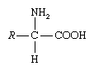
Living Organisms can obtain amino acids through the foods they eat. When proteins are digested or broken down, amino acids are left. The human body uses amino acids to make proteins to help the body:
1. Break down food
2. Growth
3. Repair body tissue
4. Perform many other body functions
5. Amino acids can also be used as a source of energy by the body.

Amino acids are normally are divided into three groups..
1. ESSENTIAL AMINO ACIDS
Essential amino acids cannot be made by the body. As a result, they must come from food. The 9 essential amino acids are: histidine, isoleucine, leucine, lysine, methionine, phenylalanine, threonine, tryptophan, and valine.
2. NONESSENTIAL AMINO ACIDS
Nonessential means that our bodies produce an amino acid, even if we do not get it from the food we eat. Nonessential amino acids include: alanine, arginine, asparagine, aspartic acid, cysteine, glutamic acid, glutamine, glycine, proline, serine, and tyrosine.
3. CONDITIONAL AMINO ACIDS
Conditional amino acids are usually not essential, except in times of illness and stress. Conditional amino acids include: arginine, cysteine, glutamine, tyrosine, glycine, ornithine, proline, and serine.
Standard classification of amino acids
One of the most useful manners by which to classify the standard (or common) amino acids is based on the polarity (that is, the distribution of electric charge) of the R group (e.g., side chain).

Group I: Nonpolar amino acids
Group I amino acids are glycine, alanine, valine, leucine, isoleucine, proline, phenylalanine, methionine, and tryptophan. The R groups of these amino acids have either aliphatic or aromatic groups. This makes them hydrophobic (“water fearing”). In aqueous solutions, globular proteins will fold into a three-dimensional shape to bury these hydrophobic side chains in the protein interior. The chemical structures of Group I amino acids are:
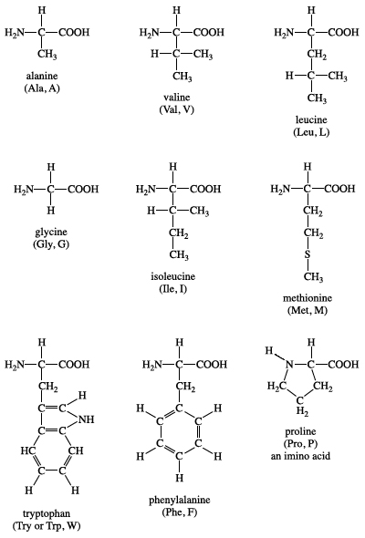
Group II: Polar, uncharged amino acids
Group II amino acids are serine, cysteine, threonine, tyrosine, asparagine, and glutamine. The side chains in this group possess a spectrum of functional groups. However, most have at least one atom (nitrogen, oxygen, or sulfur) with electron pairs available for hydrogen bonding to water and other molecules. The chemical structures of Group II amino acids are:
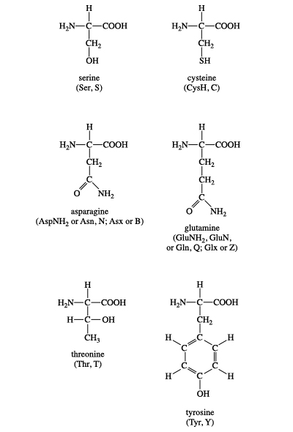

Group III: Acidic amino acids
The two amino acids in this group are aspartic acid and glutamic acid. Each has a carboxylic acid on its side chain that gives it acidic (proton-donating) properties. In an aqueous solution at physiological pH, all three functional groups on these amino acids will ionize, thus giving an overall charge of −1. In the ionic forms, the amino acids are called aspartate and glutamate. The chemical structures of Group III amino acids are
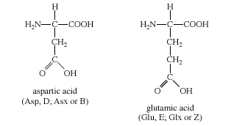
Group IV: Basic amino acids
The three amino acids in this group are arginine, histidine, and lysine. Each side chain is basic (i.e., can accept a proton). Lysine and arginine both exist with an overall charge of +1 at physiological pH. The guanidino group in arginine’s side chain is the most basic of all R groups (a fact reflected in its pKa value of 12.5). As mentioned above for aspartate and glutamate, the side chains of arginine and lysine also form ionic bonds. The chemical structures of Group IV amino acids are..
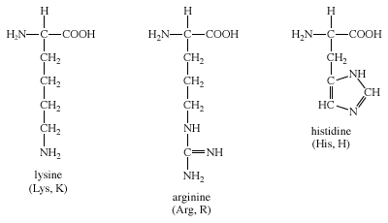

Building blocks of proteins
Proteins are of primary importance to the continuing functioning of life on Earth. Proteins catalyze the vast majority of chemical reactions that occur in the cell. They provide many of the structural elements of a cell, and they help to bind cells together into tissues. Some proteins act as contractile elements to make movement possible. Others are responsible for the transport of vital materials from the outside of the cell (“extracellular”) to its inside (“intracellular”). Proteins, in the form of antibodies, protect animals from disease and, in the form of interferon, mount an intracellular attack against viruses that have eluded destruction by the antibodies and other immune system defenses. Many hormones are proteins. Last but certainly not least, proteins control the activity of genes (“gene expression”).
This plethora of vital tasks is reflected in the incredible spectrum of known proteins that vary markedly in their overall size, shape, and charge. By the end of the 19th century, scientists appreciated that, although there exist many different kinds of proteins in nature, all proteins upon their hydrolysis yield a class of simpler compounds, the building blocks of proteins, called amino acids. The simplest amino acid is called glycine, named for its sweet taste (glyco, “sugar”). It was one of the first amino acids to be identified, having been isolated from the protein gelatin in 1820. In the mid-1950s scientists involved in elucidating the relationship between proteins and genes agreed that 20 amino acids (called standard or common amino acids) were to be considered the essential building blocks of all proteins. The last of these to be discovered, threonine, had been identified in 1935.

